**Working from Home Environment & Well-being Study Data Final Report**

**Team 1 -** Diyora Akbarkhujaeva, Fernando Kuniy, Gavin Tan, Gelila Solomon

**Correlating Flourishing Score with number of breaks:**

***Hypothesis:*** Participants who take an average of 2 or fewer breaks per day will report lower levels of subjective well-being (as measured by a score on the Flourishing Scale) than those who take an average of 4 or more breaks per day.

Here we plotted the number of average daily breaks the participants took per day against the flourishing scores. We utilized the 6-month data to observe how the flourishing scores of individuals who took two or less breaks and four or more breaks correlated to one another and how they changed over time – from the initial 2 months, to 3 months, to 4 months, and to 6 months.

Flourishing scores measure happiness and life satisfaction, mental and physical health, sense of meaning and purpose, financial and material stability, and others, questions span 6 domains and answers are given on a scale 1-10. The flourishing scores used in this data are the sums of all the answers.

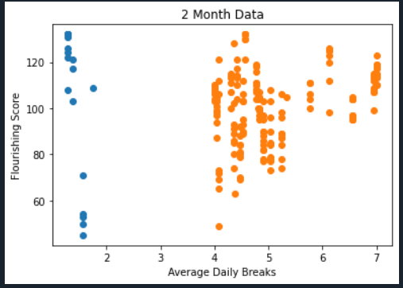

Mean flourishing score - 2 or less breaks: 107.52

Mean flourishing score - 4 or more breaks: 101.29

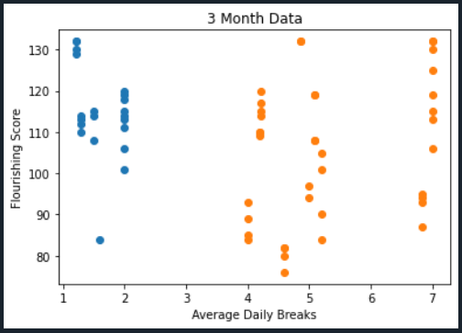

Mean flourishing score - 2 or less breaks: 114.76

Mean flourishing score - 4 or more breaks: 105.03

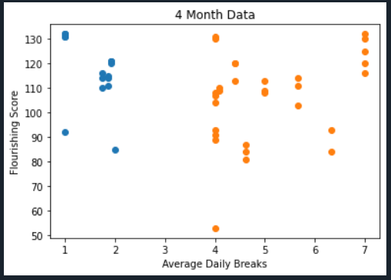

Mean flourishing score - 2 or less breaks: 117.53

Mean flourishing score - 4 or more breaks: 106.27

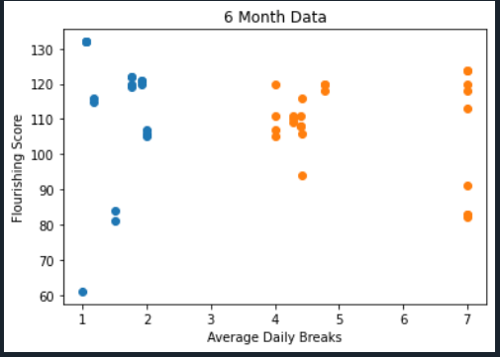

Mean flourishing score - 2 or less breaks: 113.05

Mean flourishing score - 4 or more breaks: 108.48

Overall, we have observed that individuals who took an average of 2 or less breaks per day reported a higher flourishing score than those who took an average of 4 or more breaks for all months the study was conducted in, which disproves our initial hypothesis.

Furthermore, it is important to note that the mean flourishing score of individuals who took an average of 2 or less breaks increased from the initial data gathered in the first 2 months of the study to the data collected after 4 months, but it declined from 4 months to 6 months. On the other hand, the mean flourishing score of individuals who took an average of 4 or more breaks kept increasing as the study progressed. This could potentially signify that a higher number of breaks will positively affect an individual’s well being the longer the individual spends time working from home.

**Correlating Flourishing Scores with E-work Life Scale:**

***Hypothesis****:* Subjective well-being (as measured by a score on the Flourishing Scale) will correlate positively with the E-Work Life score.

The E-Work Life Scale was measured by a survey comprising four categories: Organizational Trust, Flexibility, Work-Life Interference, and Effectiveness/Productive. Each of the categories included questions that individuals were supposed to answer on a scale from 1 to 5 (1 being strongly agree and 5 being strongly disagree).

Flourishing Score Correlation with E-work Life Scale (6 month data)

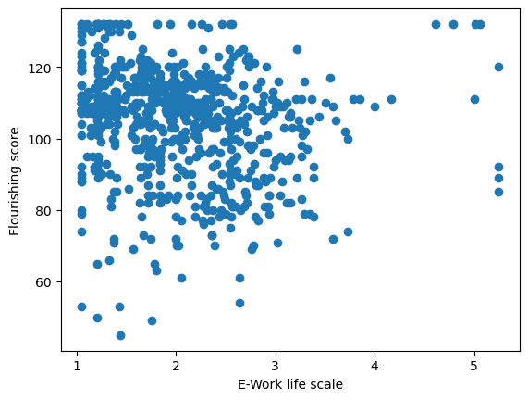

The graph above shows the correlation between the flourishing scores of individuals and their E-work life scores. We can observe that the lower the E-work life score, the higher the flourishing score. The calculated p value was 0.000015, which further supports that the subjective well being will correlate positively with E-work life score.

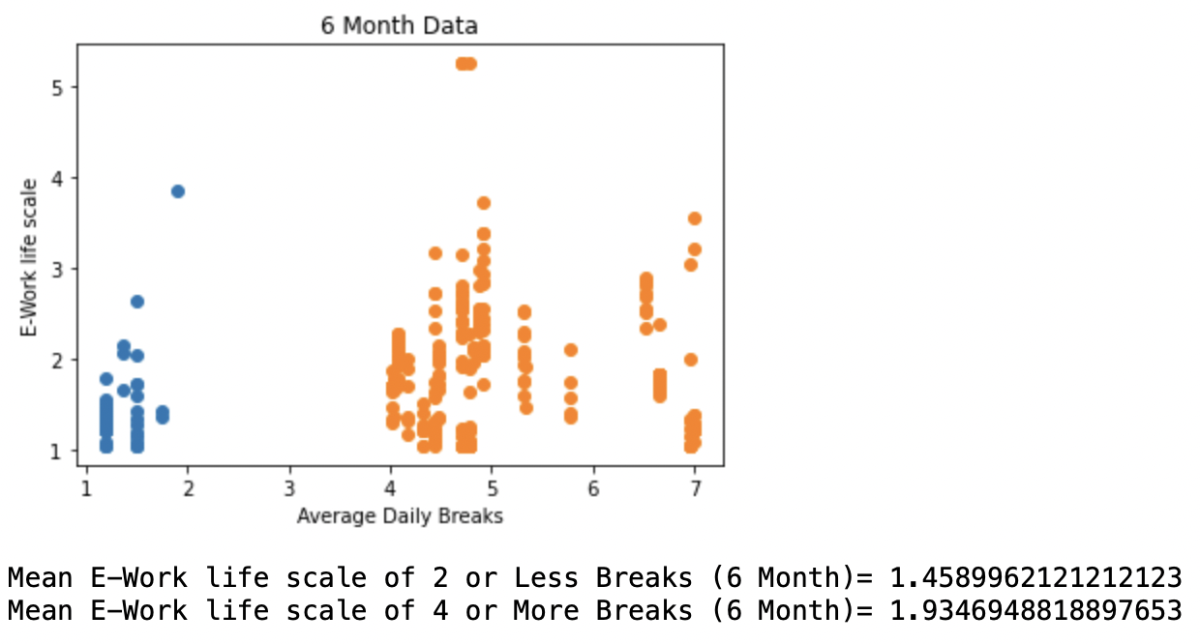

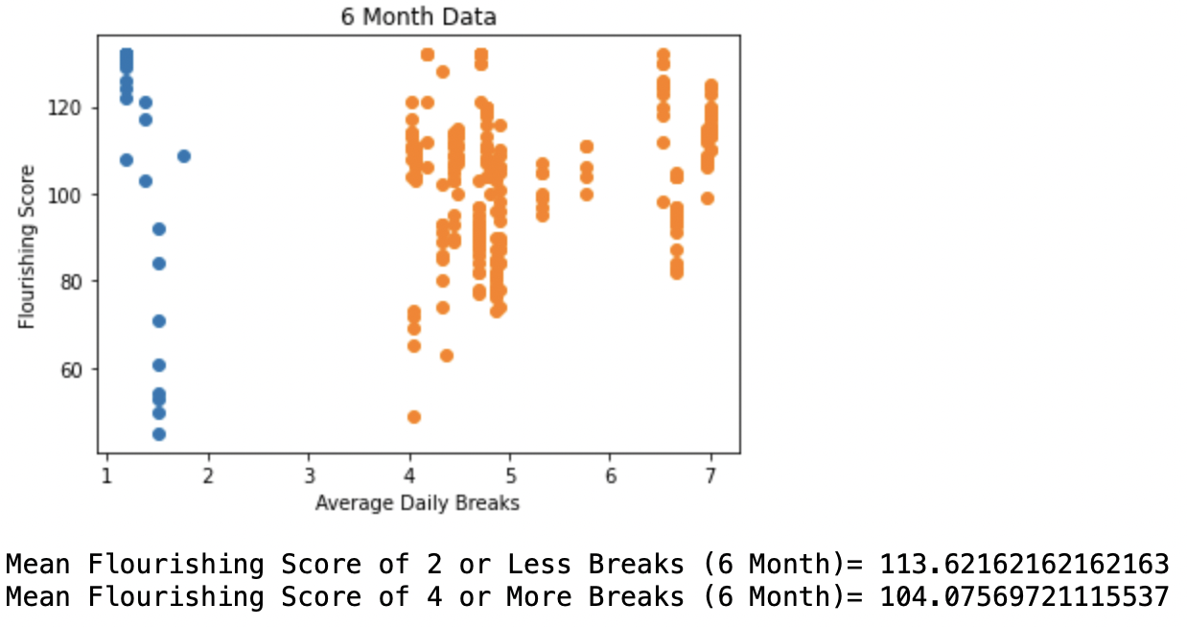

As we further analyzed the data taking into account the average number of breaks individuals took, we observed that those who took an average of two or less breaks per day presented a mean E-Work Life score that was lesser than those who took an average of four or more breaks. This discovery also supports the hypothesis since an analysis of the flourishing scores for those individuals showed that the flourishing scores for 2 or less breaks was greater than 4 or more breaks. It is important to note, however, that even though the subjective well being of individuals was positively correlated with their E-Work Life score, the difference between the well being and E-Work Life scores of individuals who took two or less breaks and four or more breaks was not significant.